Exercise #9
- List the minimum perks package.
SELECT MIN(perks) FROM employee_table;
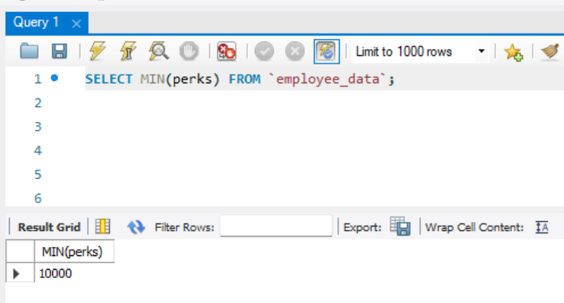
- List the maximum salary given to a “Programmer”.
SELECT MAX(salary) FROM employee_data WHERE title like ‘%programmer&’;
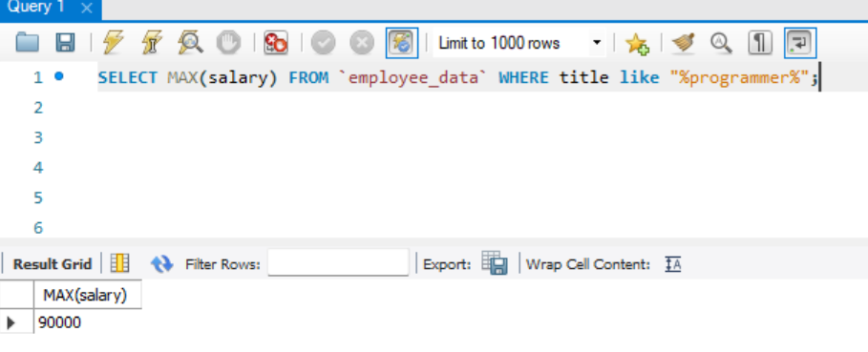
- Display the age of the oldest “Marketing Executive”.
SELECT MAX(age) FROM employee_data WHERE like ‘Marketing Executive’;
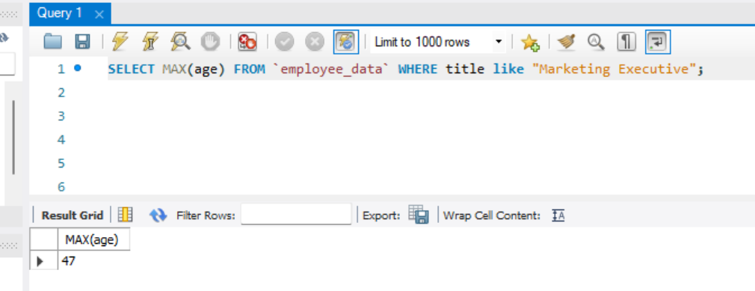

- (Tricky) Find the first and last names of the oldest employee.
SELECT f_name, l_name FROM employee_data WHERE age = (select MAX(age) from employee_data);
-- It wasn’t THAT tricky.
